Project Development Phase
Functional & Performance Testing
Date | 11 September 2026
Student Name | Yuvasri Malla
Project Name | Licensed Software Installation Request through Service Catalog
Maximum Marks

Test Scenarios & Results
Test ID | Scenario | Expected Result | Status
TC-01 | Open Service Portal | Portal loads successfully | Pass
TC-02 | View Licensed Software catalog item | Catalog item is visible | Pass
TC-03 | Open Software Request form | Request form opens | Pass
TC-04 | Enter request details | Required fields are available | Pass
TC-05 | Select licensed software | Relevant software options display | Pass
TC-06 | Validate mandatory fields | Validation works correctly | Pass
TC-07 | Submit software request | REQ and RITM are created | Pass
TC-08 | Approval process | Request is sent for approval | Pass
TC-09 | License validation & task creation | License is checked and fulfillment task is created | Pass
TC-10 | End-to-end testing | Complete request and installation flow works | Pass

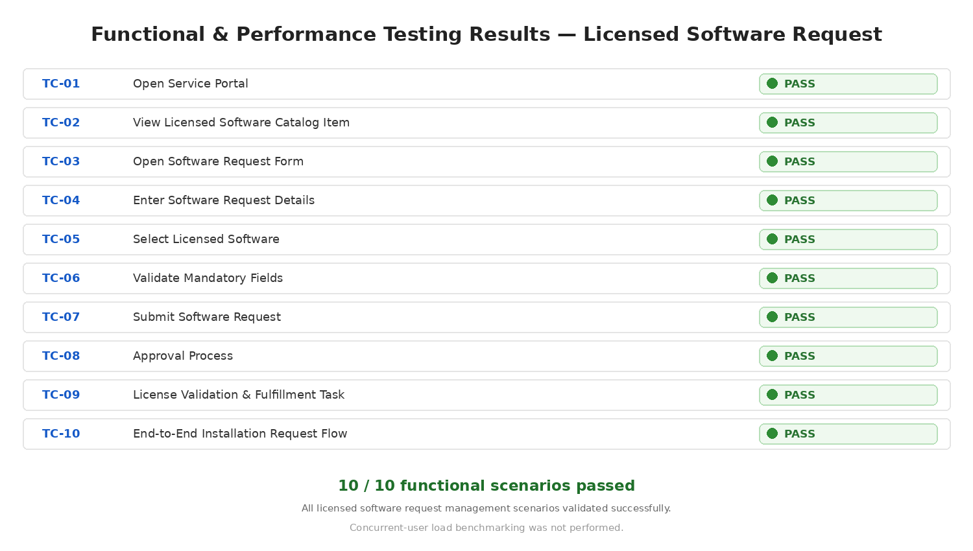
Figure 1: Functional and performance testing results for the Licensed Software Request Management project.

